SIMATS ENGINEERING

ASSESSMENT TOOL 1
Name: Thirupugazh S R
Reg No: 192371016
Marks: 91/100

COURSE NAME: INTERNET PROGRAMMING COURSE CODE: CSA43

COURSE OUTCOME COVERED

CO-1: Develop well-structured, standards-compliant web pages using HTML/XHTML and XML, and apply Internet protocols and HTTP communication mechanisms for web content delivery. (L2)

Assessment Tool: Application-Based Questions

Weightage: 40%

QUESTIONS: Total Marks: 30

1: Online Symposium Portal
A college is developing an online symposium registration portal. The following HTML structure and HTTP interaction is observed:
<form action="/register" method="POST">
<input type="text" name="name">
<input type="email" name="email">
<button>Submit</button>
</form>
When a student submits the form, the browser sends an HTTP request to the server, and the server responds accordingly.

Questions:
- Identify appropriate HTML5 semantic elements missing in the structure.
- Modify the structure to make it standards-compliant.
- Interpret the HTTP request generated during form submission.
- Analyze the HTTP response cycle from server to browser.
- Suggest improvements for usability and accessibility.

Name: Thirupugazh S R
Reg No: 192371016

2: Cross-Browser Compatibility Issue
A company website shows inconsistent layout across browsers. The following HTML snippet is used:
<html>
<head>
<title>Company</title>
</head>
<body>
<div>
<h1>Welcome
<p>About us
</div>
</body>
</html>

Questions:
- Identify improper nesting and missing closing tags.
- Analyze how different browsers may interpret this structure.
- Identify missing semantic elements (e.g., header, section).
- Provide a corrected W3C-compliant HTML structure.
- Suggest techniques to ensure cross-browser compatibility.

3: Form Submission Failure
A web application fails to send form data to the server. The following configuration is observed:
<form action="/submit" method="GET">
<input type="text" name="username">
<input type="password" name="password">
<button type="button">Login</button>
</form>

Questions:
- Identify issues in the form configuration.
- Analyze why the HTTP request is not triggered.
- Interpret the role of GET method in this scenario.
- Propose a corrected implementation.
- Suggest improvements for secure data transmission.

Code of Conduct:

I Thirupugazh S R / 192371016 (Name / Reg No) certify that this submission is my original work and that I have adhered to the guidelines specified for this assessment.
I understand that any violation of academic integrity rules will result in disciplinary action.

Signature of the student: Thirupugazh S R

RUBRICS FOR CALCULATION:

Criteria | Weig htage | Level 4 – Exemplary | Level 3 – Proficient | Level 2 – Developing | Level 1 – Beginning | Estimated Score
Understanding of Concepts | 25% | Demonstrates thorough, accurate understanding of concepts | Good understanding with minor gaps | Basic understanding with some misconception  s | Poor understandin g; major misconceptio  ns | 23/25
Explanation | 25% | Detailed, well-explained answers with relevant  examples | Clear explanation with adequate  details | Limited explanation; lacks depth | Poor or unclear explanation | 22/25
Application | 20% | Effectively applies concepts with strong analytical ability | Applies concepts with minor errors | Limited application with weak  analysis | No application or incorrect  analysis | 18/20
Organization | 15% | Well-structured answers with logical flow and coherence | Organized with minor issues in flow | Basic structure, lacks clarity | Poor organization, incoherent  answers | 14/15
Accuracy | 10% | Completely accurate and covers all  required points | Mostly accurate with minor  omissions | Partially correct with  missing points | Incorrect answers with  major gaps | 9/10
Clarity | 5% | Clear, neat, professional presentation | Understandable with minor issues | Limited clarity, readability issues | Poorly written, difficult to  understand | 5/5
Total | 100% | Estimated Total |  |  |  | 91/100
1: Online Symposium Portal
A college is developing an online symposium registration portal. The following HTML structure and HTTP interaction is observed:
<form action="/register" method="POST">
<input type="text" name="name">
<input type="email" name="email">
<button>Submit</button>
</form>

When a student submits the form, the browser sends an HTTP request to the server, and the server responds accordingly.
Questions:
1. Identify appropriate HTML5 semantic elements missing in the structure.
2. Modify the structure to make it standards-compliant.
3. Interpret the HTTP request generated during form submission.
4. Analyze the HTTP response cycle from server to browser.
5. Suggest improvements for usability and accessibility.

Answer 1 – Missing HTML5 semantic elements
The given snippet is only a bare <form>. It has no document skeleton and none of the HTML5 elements that describe the meaning of each part of a page:
Missing element | Purpose / why it is needed
<!DOCTYPE html>, <html lang>, <head>, <meta charset>, <title> | Puts the browser in standards mode, declares the language and character set, and gives the page a title (needed by screen readers and search engines).
<header> | Holds the portal title / logo and introductory content.
<nav> | Groups the navigation links (Home, Events, Contact).
<main> | Marks the unique, primary content of the page (the registration area).
<section> (with heading) | Groups the "Student Registration" content as a thematic block.
<fieldset> and <legend> | Groups related form controls and gives the group a name.
<label> | Associates a visible text caption with each <input>; the inputs currently have none.
<footer> | Copyright / contact information at the end of the page.

Answer 2 – Standards-compliant (W3C valid) structure
Changes made: added DOCTYPE, html/head/body, charset, viewport and title; wrapped the content in header, nav, main, section and footer; added <fieldset>/<legend>; linked every <label> to its input using for/id; added the required, autocomplete and placeholder attributes; and gave the button an explicit type="submit".
<!DOCTYPE html>
<html lang="en">
<head>
<meta charset="UTF-8">
<meta name="viewport" content="width=device-width, initial-scale=1.0">
<title>Online Symposium Registration</title>
<style> /* page styling */ </style>
</head>
<body>
<header>
<h1>SIMATS Online Symposium</h1>
<nav aria-label="Main"><a href="#">Home</a><a href="#">Events</a><a href="#">Contact</a></nav>
</header>
<main>
<section aria-labelledby="reg-title">
<h2 id="reg-title">Student Registration</h2>
<form action="/register" method="POST">
<fieldset>
<legend>Participant details</legend>
<label for="name">Full Name</label>
<input type="text" id="name" name="name" placeholder="e.g. Thirupugazh S R" autocomplete="name" required>
<label for="email">Email Address</label>
<input type="email" id="email" name="email" placeholder="you@college.edu" autocomplete="email" required>
<button type="submit">Submit</button>
</fieldset>
</form>
</section>
</main>
<footer><p>&copy; 2026 SIMATS Engineering. All rights reserved.</p></footer>
</body>
</html>

Answer 3 – Interpreting the HTTP request generated on submission
Because method="POST" and action="/register", the browser collects every control that has a name attribute, URL-encodes the data (default enctype application/x-www-form-urlencoded) and sends it in the body of the request. The request below was captured from the corrected form (see Output screen):
POST /register HTTP/1.1
Host: 127.0.0.1:8765
Content-Type: application/x-www-form-urlencoded
Content-Length: 51
Origin: http://127.0.0.1:8765
Referer: http://127.0.0.1:8765/q1.html

name=Thirupugazh+S+R&email=thirupugazh%40simats.edu

Part | Meaning
Request line | Method = POST (send data to the server), target = /register (from action), protocol = HTTP/1.1.
Host | Server to which the request is addressed (required in HTTP/1.1).
Content-Type | Tells the server the body is encoded as key=value pairs joined by &.
Content-Length | Size of the body in bytes (51).
Origin / Referer | The page from which the request was made (used for security checks such as CSRF).
Body | name=Thirupugazh+S+R & email=thirupugazh%40simats.edu. Spaces become "+", "@" becomes %40. The data is not shown in the URL.

Answer 4 – HTTP request–response cycle (server to browser)
• Browser sends request: after DNS lookup and TCP (and TLS, if HTTPS) connection set-up, the POST request is sent to the server.
• Server receives and routes: the web server passes /register to the application, which reads and validates name and email.
• Server processes: the data is stored (e.g. inserted into the registration database) and a confirmation e-mail may be triggered.
• Server builds the response: a status line, response headers and a body, for example:
HTTP/1.1 200 OK
Content-Type: text/html; charset=UTF-8
Content-Length: 463
Cache-Control: no-store
Date: Sat, 10 Oct 2026 05:52:59 GMT
Server: BaseHTTP/0.6 Python/3.12.3

<h2>Registration Successful</h2> ...

• Browser receives and renders: it reads the status code and headers, parses the HTML body, builds the DOM and displays the "Registration Successful" page. If the server had replied 302 Found with a Location header, the browser would automatically issue a new GET to that URL (Post/Redirect/Get pattern, which prevents duplicate submissions on refresh).
• Connection: the connection is reused (keep-alive) or closed; HTTP itself is stateless, so cookies/sessions are used to remember the user.
Status code | Meaning in this scenario
200 OK | Registration processed; page returned.
302 Found | Redirect to a "thank-you" page.
400 Bad Request | Invalid or missing data (e.g. malformed e-mail).
404 Not Found | /register route does not exist on the server.
500 Internal Server Error | Server-side failure while saving the data.

Answer 5 – Improvements for usability and accessibility
• Use <label for="…"> with matching id on every input so that clicking the label focuses the field and screen readers announce it.
• Use required, type="email", pattern/minlength for instant client-side validation, and repeat all validation on the server.
• Add autocomplete="name"/"email" and meaningful placeholder text (placeholder must not replace the label).
• Add <html lang="en">, a descriptive <title>, headings in logical order, and aria-label / aria-labelledby on landmarks (nav, section).
• Ensure keyboard access (logical tab order, visible :focus outline) and sufficient colour contrast (WCAG 2.1 AA, at least 4.5:1).
• Show clear success/error messages next to the field (aria-live="polite") and keep entered values after an error.
• Make the page responsive (viewport meta tag, flexible widths, large touch-friendly buttons).
• Send the form over HTTPS and add a CSRF token to protect personal data.
Output Screen – Question 1
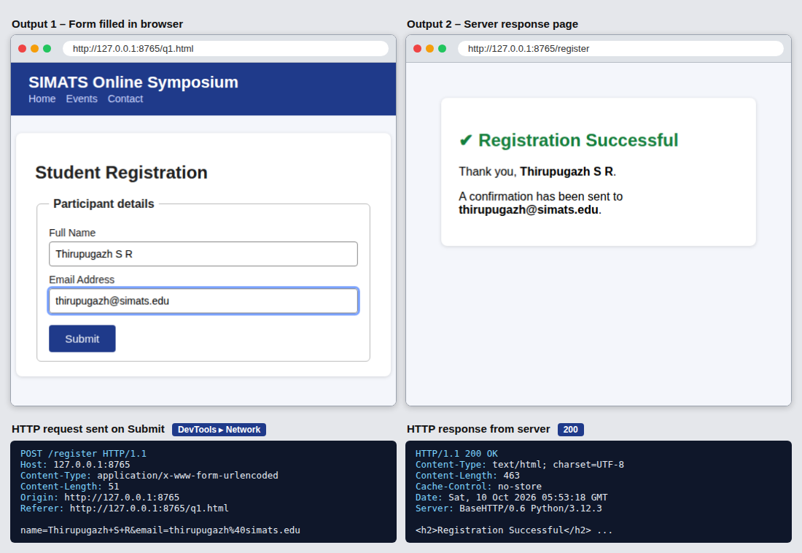
Figure 1: Corrected registration form, server response, and the captured HTTP request/response.
2: Cross-Browser Compatibility Issue
A company website shows inconsistent layout across browsers. The following HTML snippet is used:
<html>
<head>
<title>Company</title>
</head>
<body>
<div>
<h1>Welcome
<p>About us
</div>
</body>
</html>

Questions:
1. Identify improper nesting and missing closing tags.
2. Analyze how different browsers may interpret this structure.
3. Identify missing semantic elements (e.g., header, section).
4. Provide a corrected W3C-compliant HTML structure.
5. Suggest techniques to ensure cross-browser compatibility.

Answer 1 – Improper nesting and missing closing tags
• <h1>Welcome has no closing </h1> tag.
• <p>About us has no closing </p> tag (omitting it is tolerated in HTML5 but is invalid in XHTML and poor practice).
• The <p> is opened while <h1> is still open, so a block-level paragraph is nested inside a heading. A heading may contain only phrasing (inline) content, so this nesting is invalid.
• The </div> tag arrives while <h1> and <p> are still open, so the div is closed in the wrong order (elements must be closed in reverse order of opening).
• The page also lacks <!DOCTYPE html>, the lang attribute on <html>, <meta charset> and a viewport meta tag.
Answer 2 – How different browsers may interpret the structure
Invalid HTML is not rejected; each browser repairs it using its own error-recovery rules. Modern browsers follow the HTML5 parsing algorithm and give the same repaired DOM, but older or non-standard engines may differ. When the given code was loaded in Chromium, the DOM it built was:
<div>
<h1>Welcome
<p>About us
</p></h1></div>

• Modern browsers (Chrome, Firefox, Edge, Safari): the paragraph ends up inside the <h1>, so "About us" is displayed in heading size and bold (see Output screen) instead of as normal paragraph text.
• Older engines / lenient parsers (e.g. old Internet Explorer): may auto-close the <h1> before the <p>, giving a different DOM, so margins and font sizes differ from other browsers.
• No DOCTYPE: the page is rendered in quirks mode, where the box model, line-height, default fonts and table/inherit rules differ between browsers; this is the main cause of the inconsistent layout.
• Different default style sheets: each browser has its own default margins for h1 and p, which are exposed when markup is invalid.
Answer 3 – Missing semantic elements
The page uses only a generic <div>. The following elements are missing: <header> (site title and navigation), <nav> (menu links), <main> (primary content), <section> / <article> with its own heading (the "About Us" content), and <footer> (copyright and contact information).
Answer 4 – Corrected W3C-compliant HTML structure
<!DOCTYPE html>
<html lang="en">
<head>
<meta charset="UTF-8">
<meta name="viewport" content="width=device-width, initial-scale=1.0">
<title>Company</title>
<style> /* page styling */ </style>
</head>
<body>
<header>
<h1>Welcome</h1>
<nav><a href="#about">About</a><a href="#">Services</a><a href="#">Contact</a></nav>
</header>
<main>
<section id="about">
<h2>About Us</h2>
<p>About us</p>
</section>
</main>
<footer><p>&copy; 2026 Company</p></footer>
</body>
</html>

Answer 5 – Techniques to ensure cross-browser compatibility
• Always declare <!DOCTYPE html> so every browser uses standards mode, and validate the markup with the W3C Markup Validator.
• Write well-formed HTML: proper nesting, closed tags, lowercase names, quoted attributes.
• Use semantic HTML5 elements (header, nav, main, section, footer) instead of anonymous divs.
• Reset or normalise default styles (normalize.css / CSS reset) so all browsers start from the same baseline.
• Use modern, widely supported layout methods (Flexbox, Grid, relative units) and responsive design with the viewport meta tag and media queries.
• Use feature detection (@supports, Modernizr) and progressive enhancement/polyfills instead of browser sniffing; check support on caniuse.com.
• Add vendor prefixes automatically with Autoprefixer, and specify fallback fonts.
• Test on real browsers and devices (Chrome, Firefox, Edge, Safari; desktop and mobile) using DevTools device mode or tools such as BrowserStack.
Output Screen – Question 2
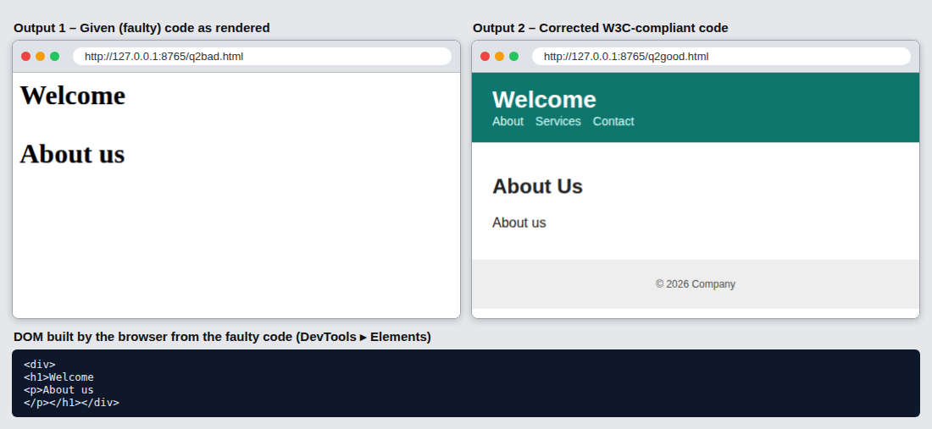
Figure 2: Given faulty code vs corrected code as rendered by the browser, with the DOM produced from the faulty code.
3: Form Submission Failure
A web application fails to send form data to the server. The following configuration is observed:
<form action="/submit" method="GET">
<input type="text" name="username">
<input type="password" name="password">
<button type="button">Login</button>
</form>

Questions:
1. Identify issues in the form configuration.
2. Analyze why the HTTP request is not triggered.
3. Interpret the role of GET method in this scenario.
4. Propose a corrected implementation.
5. Suggest improvements for secure data transmission.

Answer 1 – Issues in the form configuration
• <button type="button"> is a plain button with no submit behaviour, so clicking it never submits the form. This is the main cause of the failure.
• method="GET" is used for a login form, so the username and password would be appended to the URL if the form were submitted.
• The inputs have no id and no <label>, which makes the form inaccessible and hard to use.
• No required/validation attributes, no autocomplete attributes, no minlength for the password.
• There is no HTML skeleton (DOCTYPE, head, title, charset) and no HTTPS is enforced.
Answer 2 – Why the HTTP request is not triggered
A form is submitted only when the user activates a submit control: <button type="submit">, <input type="submit"> or a button with no type (default is submit), or when JavaScript calls form.submit(). A button with type="button" has no default action, and here there is no onclick handler or script attached, so no event ever tells the browser to build the request. As a result, no request reaches /submit, the page does not reload and the address bar does not change. The output screen confirms this: the browser Network panel shows 0 requests after clicking Login.
Answer 3 – Role of the GET method in this scenario
GET sends form fields as a query string in the URL, e.g. /submit?username=thirupugazh&password=Secret%40123. GET is meant for safe, idempotent data retrieval (searching, filtering). For a login form it is unsuitable because:
• The password is visible in the address bar, browser history, bookmarks and shoulder-surfing.
• It is stored in server/proxy logs and may leak through the Referer header.
• URLs have length limits and can be cached.
• The request can be repeated by simply revisiting the link.
Even after fixing the button, GET must therefore be replaced by POST, which carries the data in the request body.
Feature | GET | POST
Data location | URL query string | Request body
Visible in URL/history | Yes | No
Typical use | Retrieve / search | Login, registration, create/update
Size limit | About 2 KB (browser dependent) | Practically none
Bookmarkable / cached | Yes | No

Answer 4 – Corrected implementation
<!DOCTYPE html>
<html lang="en">
<head>
<meta charset="UTF-8">
<meta name="viewport" content="width=device-width, initial-scale=1.0">
<title>Secure Login</title>
<style> /* page styling */ </style>
</head>
<body>
<main>
<h1>User Login</h1>
<form action="/submit" method="POST">
<label for="username">Username</label>
<input type="text" id="username" name="username" autocomplete="username" required>
<label for="password">Password</label>
<input type="password" id="password" name="password" autocomplete="current-password" minlength="8" required>
<button type="submit">Login</button>
</form>
</main>
</body>
</html>

Fixes: type="submit" so the click triggers the request; method="POST" so the credentials travel in the body; labels linked to ids; required, minlength and autocomplete attributes added.
Answer 5 – Improvements for secure data transmission
• Serve the page and the /submit endpoint over HTTPS (TLS) and enable HSTS so credentials are encrypted in transit.
• Use POST only; never put credentials in the URL.
• Store passwords on the server as salted hashes (bcrypt / Argon2), never in plain text; never log them.
• Add a CSRF token and set cookies with HttpOnly, Secure and SameSite flags.
• Validate and sanitise all input on the server to prevent SQL injection and XSS.
• Apply rate limiting / account lock-out and CAPTCHA to stop brute-force attacks; consider multi-factor authentication.
• Return generic error messages ("Invalid username or password") and use a Content-Security-Policy header.
Output Screen – Question 3
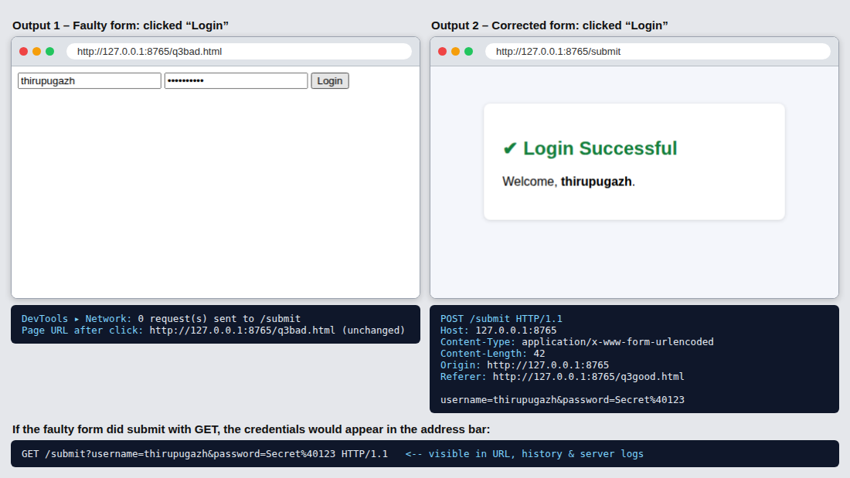
Figure 3: Faulty form (no request sent) vs corrected form (POST request sent and login successful).

